# Monitor DTCC Portal Transactions Procedure

Service Level Management

**Purpose**

How to identify and document DTCC Web Services (transactions) are meeting their SLA targets using the DTCC Portal. The Portal will be checked daily and the totals logged in the monthly DTCC Transaction Spreadsheet. These totals will be used in the Monthly KPI report. There are currently six services actively being used:

* 102 Fund Transfer Service (fund transfer business capability - financial)
* 103 Attachments
* 105 Withdrawals Service (one-time withdrawals business capability - financial)
* 107 Arrangements Service (for both business capabilities: fund transfer and withdrawal –financial)
* 113 Policy Administration
* 212 Value Inquiries Service (for both business capabilities: fund transfer and withdrawal – non-financial)

**Related Policy**

* [IT Service Management Policy](https://sharepoint.jackson.com/sites/itsmsd/servicelevelmanagement/Shared%20Documents/Pre%20December%202019/SLM%20Documents/Policy%2C%20Process%2C%20Procedures/SLM_Service%20Level%20Management%20Process.doc?d=wa1eaba53e1dc4b30abda2a0886981cc9)

**Audience**

The following groups are responsible for adhering to this document:

* Service Level Management

**Procedure**

|  |  |
| --- | --- |
| Step | Action |
| 1 | Log into [DTCC Portal](https://portal.dtcc.com/tbr/tb/html/pages?TAM_OP=login&ERROR_CODE=0x00000000&URL=%2F)   * There are two logins one with a “1” on the end is for JNY (participant number 4584) and Brooke Life (we should not have any of Brooke Life which is participant number 4581) and the one without the “1” is for JNL (participant number 4552). |
| 2 | Click on Insurance & Retirement Services |
| 3 | Click on Messaging Dashboard |
| 4 | Click on Search Messages and click on tab Submit |
| 5 | You will be presented with the list of services to choose from: |
| 6 | Click on service you want to check (for this example we used Value Inquiry), the following screen will be displayed:     1. Enter the date you which to run the search for 2. Click on the Participant Number    * Because the login used is for JNL, there is only one participant number 4552 (for JNL). When there is more than one, hold down the shift and select all.    * Do not put anything in the Participant Indicator, Contra Participant Number, or the Transaction Reference GUID.   ***Note:*** *You do not need to enter the transaction type it is already set*   1. Click the Search button |
| 7 | A screen will display the results: |
| 8 | Click on the export for Excel in the lower right corner     * Click open when asked what you want to do      * If you get this popup click “Yes” |
| 9 | A spreadsheet will open.   * Delete the column GUID * Reformat the column Transaction Timestamp to be mm/dd/yy HH:MM * Click in the upper left of the spreadsheet to highlight all rows and columns. * Click sort and filter in the upper right of the tool bar   + Click custom sort   + Sort by Transaction Timestamp   + Click the center horizonal and the center vertically buttons at the top of the screen. * Add 2 columns to the end with the header of:  |  |  | | --- | --- | | **Comment** | **System Outage?** | |
| 10 | Day 1 Response Status actions   * Click in the upper left of the spreadsheet to highlight all rows and columns. * Click custom sort * Sort by column “Day 1 Response Status” * Go to the bottom and check for messages * If there are messages for “Timeouts”:   + Under comment column for that row enter “Time out”   + Under “System Outage?” column enter “Yes”(see **Step 13** for further action). |
| 11 | Receiver Response Status   * Click in the upper left of the spreadsheet to highlight all rows and columns. * Click custom sort * Sort by column “Receiver Response Status” * Go to the bottom and check for messages * If there are messages for “Rejected”   + Click the “Accepted” link under the ‘Day 1 Response Status’ column next to the “Receiver Rejected” link.   + Review the log for the error message. It will begin with a “tc” code.   + Enter the code and error message to the corresponding row of the spreadsheet.   + If it is code TC300, enter “Yes” under the “System Outage?” column. (see **Step 13** for further action).   + If it is any other code, enter “No” under the “System Outage?” column. |
| 12 | Update the monthly tracking spreadsheet entitled *##-Month DTCC Transactions.xlsx* located at:  O:\share\Service Delivery\Service Level Management\SLA Reporting\Reporting\Year\Daily SLA Report\Month\DTCC Transactions   1. In the “TMP” spreadsheet, select the first row after the header row through the last row:    * Right click and select copy    * Go to the spreadsheet for the DTCC Transactions spreadsheet for the month    * Select the tab for the service (Arrangement, Fund Transfer, etc.,)    * Click on the summary row for the company that you are working on, at the bottom of that section    * Right click and click “Insert Copied Cells.    * Make sure the summary is counting down to the last row. 2. Repeat until all Transaction types are updated in the spreadsheet. 3. If there were no transactions for the date, type “Checked through XX/XX/XXXX – no further transactions” under the summary section. |
| 13 | If any “Timeouts” or “TC=300, System Not Available” errors are found:   1. Create an Incident ticket in Remedy:  * **Notes:** DTCC Transactions – *Transaction Type* – Failed Transactions on MM/DD/YYYY * **Summary:** DTCC Transactions – *Transaction Type –* Failed Transactions on MM/DD/YYYY * **Service:** DTCC Services Tech Service * **Severity:** Service Request * **Impact:** 2-Significant / Large * **Urgency:** High * **Reported Source:** Direct Input * **Categorization Tab / Tier 1+:** Investigate * **Categorization Tab / Tier 2+:** Application Service * Attach a word document with a screen shot of the errors found * Use the “Auto-Assign” option to assign ticket to the correct team.   Under the “Quick Action” section in Remedy.     1. (Optional) Send email to TM Hutsell team and reference the Incident ticket that was created.   *See* ***Appendix B*** *for email example.*   1. Review the Incident ticket by the start of the next month to see if Service Level Management has been instructed to apply a carve-out. 2. If instructed to apply a carve-out, add the reason and Problem or Incident ticket numbers provided to the comment cell of the spreadsheet located in **Step 12** and the CPI report. 3. The “Yes” statement will have to be updated to “No” for the carve-out to be applied. |
| 14 | The data from the spreadsheet will be copied weekly into the CPI report (CPI APP 1.4).  [CPI Report on SharePoint](https://sharepoint.jackson.com/sites/itsmsd/servicelevelmanagement/_layouts/15/start.aspx#/SitePages/Home.aspx?RootFolder=%2Fsites%2Fitsmsd%2Fservicelevelmanagement%2FShared%20Documents%2FCPI%20Reporting&FolderCTID=0x012000C3EC5FEE7B19F646BACB9A57478C774E&View=%7B9B9C91F7%2D03BB%2D4B05%2D914F%2D8269C014311D%7D)  When the spreadsheet is completed for the month, save to SharePoint at the following location:  [Daily Reporting\SLM\YYYY\Daily SLA Report\Month](http://docs.jackson.local/it/sites/rs/_layouts/15/start.aspx#/Daily%20Reporting/Forms/current.aspx?RootFolder=%2Fit%2Fsites%2Frs%2FDaily%20Reporting%2FSLM&View=%7B1D5400F7%2DF40D%2D4DC8%2DAED7%2DCCDABECB8C2F%7D)\DTCC Transactions |

**Appendix A**

[I&RS Messaging Dashboard](O:\\share\\Service Delivery\\Service Level Management\\SLA Information)

**Appendix B – Example Email to TM Hutsell Team**

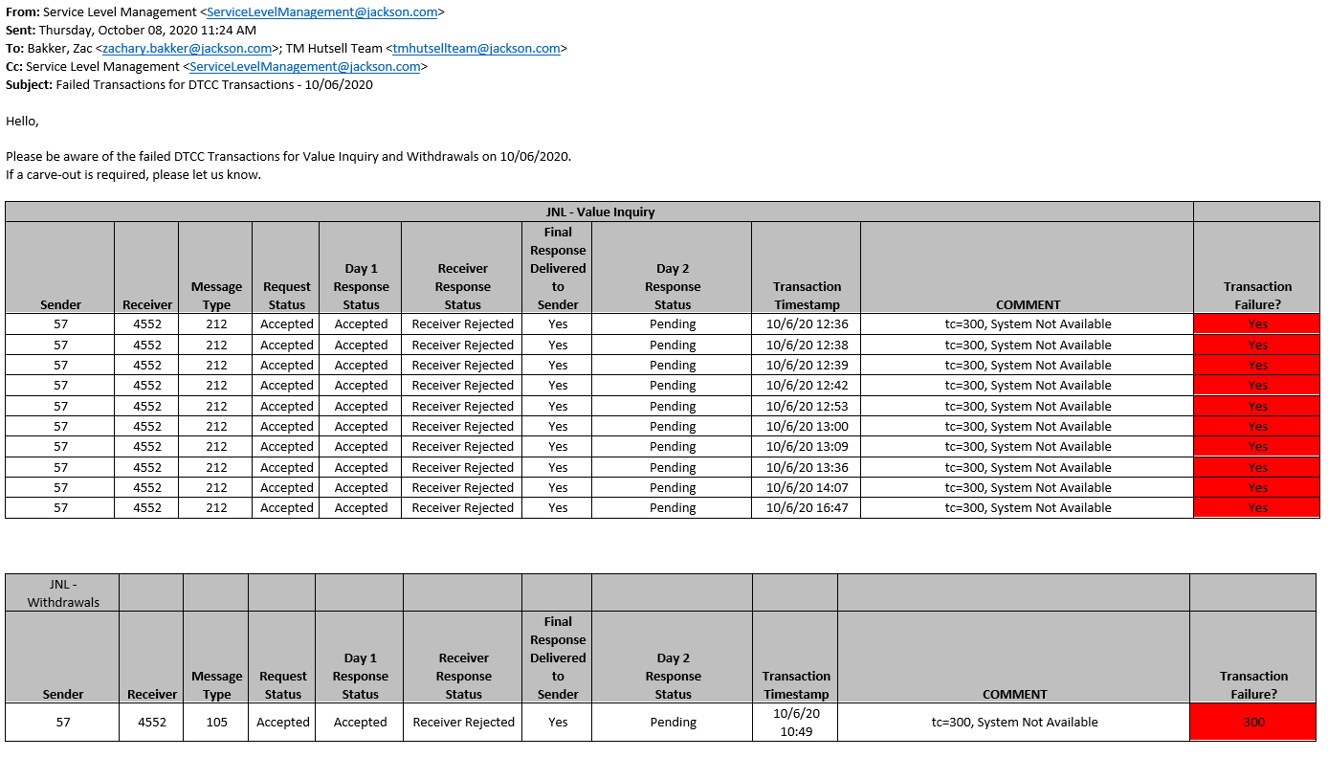

**Modification**

The following associates can make modifications to this document:

* Manager, Service Level Management
* Director, IT Service Management
* Vice President, Service Delivery
* Chief Technology Officer, PGDS

|  |  |
| --- | --- |
| Service Level Management Process | |
| Responsible Party: Sharla Piepkow, Manager, Service Level Management Approving Authority: Rob Kolm, Director, IT Service Management | Date Created: 11/19/2018 Last Modified: 05/19/2020 Last Reviewed: |